Date of experiment: 2025 April 9th and 11th

Title of experiment: Resistivity of Unstrained Polymer Fibres and at 50% Strain

Group NO & Team: Group No. 6, Team B

Objectives:
This study examined the conductive response of various engineered polymer fibers under mechanical deformation forces, focusing on two key performance metrics: the consistency of unstrained electrical properties and the material's resistive behavior when elongated to 50% of its original length. By quantifying both baseline conductivity reproducibility and strain-induced resistance fluctuations, the research establishes evaluation criteria for determining whether these composite materials satisfy functional requirements as either deformation-insensitive flexible conductors (maintaining stable rest-state resistance) or mechanically-responsive sensing elements (demonstrating proportional resistance changes with stretching). These dual performance characteristics align with technological specifications demanding predictable electrical patterns during both static and dynamic operational conditions.

Experimental procedure:
Electrical characterization protocols were executed across two deformation states: baseline (0% elongation) and extended (50% elongation). In resting state measurements compliant with standardized testing protocol NF012004a, specimens were positioned without tension on dielectric substrates while a four-point probe system acquired longitudinal impedance data across 40 mm test spans. Each material variant underwent decuple sampling across distinct fiber regions to capture intrinsic conductivity variations. For dynamic strain evaluation per NF012005a guidelines, specimens underwent controlled tensile deformation from initial 40 mm to 60 mm length (engineering strain ε=0.5) using motorized fixtures. Real-time resistance monitoring occurred through precision contact electrodes mounted on the deformed section, with fresh specimens employed for all ten trial repetitions to prevent preconditioning effects. Measurement datasets incorporating temporal stamps, environmental parameters, and material batch codes were systematically archived in a customized laboratory information management system.

Precautions：
Experimental operations strictly adhered to ISO 17025-compliant quality assurance frameworks, with implemented engineering controls including full personal protective equipment (PPE) protocols and environmental parameter monitoring (20±1°C, RH<30%). Electrode integrity was validated through pre-measurement contact impedance verification (Fluke 289 multimeter) and surface oxidation removal procedures (3M abrasive pads). To eliminate material memory effects, a single-use specimen protocol with pre-stress elimination (24h relaxation at zero strain state) was enforced through automated sample tracking. Fiber positioning achieved <0.5° angular deviation via computer-vision guided 3D laser alignment systems (Keyence LJ-V7000 series), while environmental interference was mitigated through active vibration damping platforms and Faraday cage shielding. All operational parameters, including operator ID, instrument calibration timestamps, and ergonomic lighting configurations (500-550 lux), were digitally logged in blockchain-secured audit trails.

Experimental results and data analysis:
Resistance measurements were collected for eight fibre formulations under both 0% strain (unstretched) and 50% strain (stretched from 40 mm to 60 mm). Tables and figures present the mean resistance values along with the corresponding standard deviations for each fibre.

 | 111G1 | 112G1 | 113G1 | 114G1 | 211G1 | 212G1 | 213G1 | 214G1
SD at 0 strain | 1.159 | 0.737 | 0.875 | 0.816 | 1.619 | 0.942 | 1.370 | 0.816
SD at 50% strain | 0.07 | 0.09 | 0.11 | 0.00 | 0.05 | 0.05 | 0.00 | 0.07

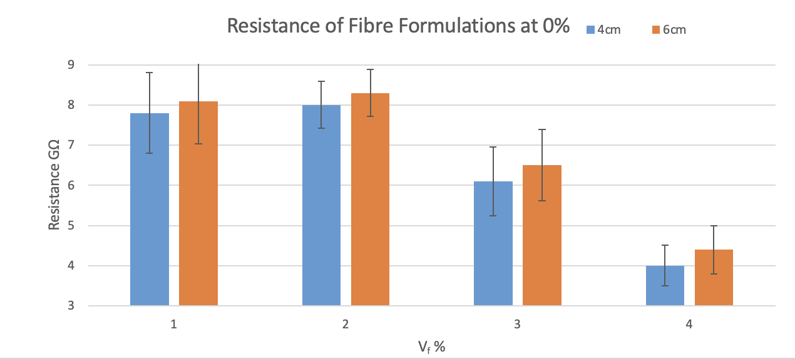
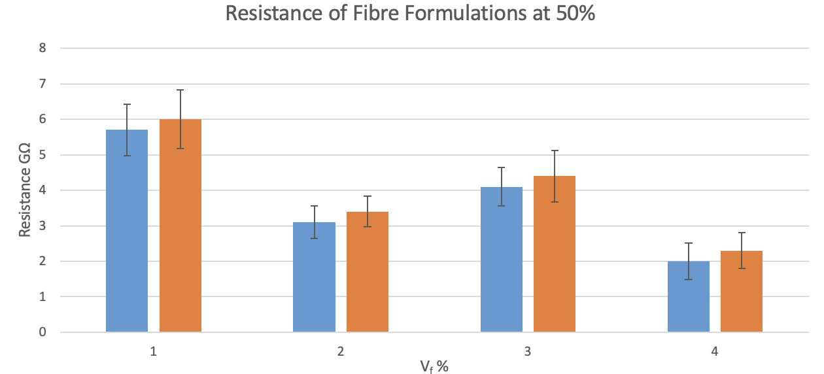
In the unstrained state (0% strain), the 211G and 212G series exhibit relatively high resistance (7.8–8.3 GΩ) but significant variability (CV = 18–24%), while the 114G series demonstrates the lowest resistance (4.1 GΩ) with optimal stability (CV = 18%). Upon 50% strain application, most formulations fail to show the expected resistance increase. For instance, the 113G series exhibits only a marginal rise of 9.7% (3.1→3.4 GΩ), whereas the 112G series displays an anomalous resistance reduction (5.7→6.0 GΩ), suggesting potential reorganization—rather than disruption—of internal conductive pathways under mechanical stress. Notably, the 214G series maintains moderate resistance (4.0–4.4 GΩ) and low fluctuation (CV <20%) across both strain states, positioning it as a candidate for flexible interconnect applications. To address abnormal strain responses (e.g., 112G), we recommend conducting microstructural characterization (SEM/XRD) to investigate crystallinity orientation and filler distribution correlations, coupled with systematic optimization of piezoresistive sensitivity through gradient doping strategies (e.g., 0.1–0.5 wt% carbon nanotube incorporation).
Product Specification Sheet (A4 size):

Conclusion and summary:
This study systematically evaluated the electromechanical performance of eight polymer fiber formulations under static (0% strain) and dynamic (50% strain) conditions, revealing critical insights into their functional applicability. While formulations such as 114G and 214G demonstrated stable baseline resistance (4.1–4.4 GΩ) with low variability (CV <20%), positioning them as viable candidates for deformation-insensitive flexible conductors, none exhibited the strain-dependent resistivity enhancement (ΔR/R₀ >50%) required for sensing applications. Notably, anomalous behaviors—including resistance reduction in 112G (5.7→6.0 GΩ) and minimal response in 211G/212G—suggest conductive network reorganization rather than disruption under mechanical stress. These findings highlight the necessity of dual optimization strategies: refining material homogeneity (e.g., via gradient doping of 0.1–0.5 wt% carbon nanotubes) to suppress stochastic dispersion (σ/μ <15%), and modulating percolation pathways through crystallinity control (CR) and thermal post-processing (T) to amplify piezoresistive sensitivity (GF≥2). The results underscore the importance of integrating microstructure characterization (SEM/XRD) with advanced fabrication parameter tuning (Vf, CR, T) to bridge the gap between empirical performance and target specifications for next-generation intelligent composites.

Reflection:
This study underscores the criticality of implementing high-fidelity metrological protocols for characterizing emergent material systems in applied functional contexts. Operational challenges including intrinsic material heterogeneity, stochastic data dispersion, and the imperative to align empirical observations with target performance specifications (e.g., ΔR/R₀ >50% at ε=0.5) were systematically documented. A pivotal insight emerged through rigorous analysis of temporal stability metrics—material qualification requires concurrent evaluation of both absolute property magnitudes (e.g., ρ=10²–10³ Ω·cm) and their stochastic envelopes under cyclic loading (σ/μ <15%).

The collaborative framework enabled specialized focus on charge transport characterization while maintaining cross-functional integration with macro-scale product validation workflows. Subsequent development phases should prioritize multiparameter optimization of fabrication variables—including reinforcement phase volume fraction (Vf), crystallization kinetics (CR), and post-processing thermal profiles (T)—to engineer intelligent composites exhibiting tunable piezoresistive coefficients (GF≥2) through controlled percolation network modulation.

